IFT 598 Topic: Data Visualization & Reporting for IT

Pranitha Nekkanti

Jahnavi Suguru

Mohammad Abdul Jabbar

Project - Phase III: Dashboard

Prof: Asmaa Elbadrawy

23rd April 2023

**Section I: Dashboard**

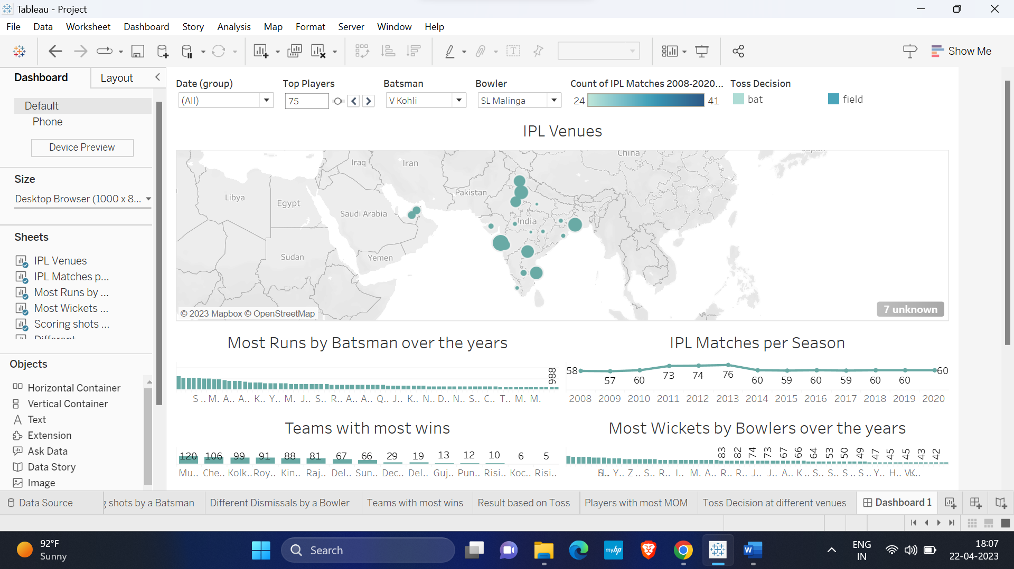

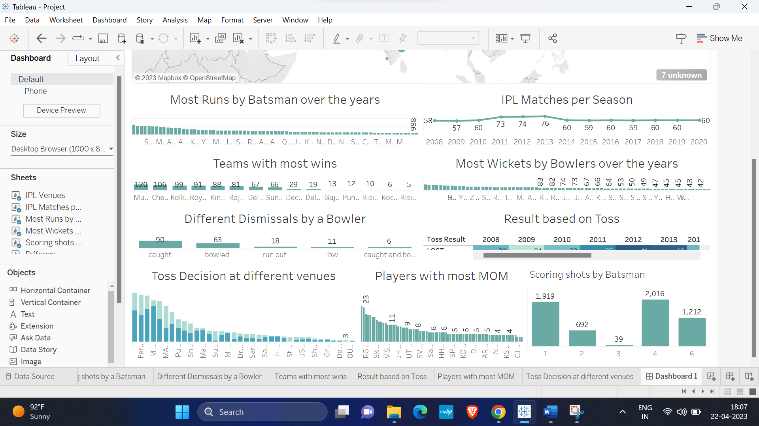

The dashboard is created by using IPL matches dataset. We have used 2 csv files such as IPL matches held between 2008 to 2020 and the runs scored in each ball in every match. The above picture shows information such as the most runs scored by all the batsman and most wickets by bowlers over the years, the team with most wins, the different venues where the matches has been held, different dismissals by bowler, the total number of 1’s,2’s,3’s,4’s,5’s and 6’s in every match, players with most MOM, match decision based on toss and toss decision at different venues.

**Section II: Dataset**

The IPL (Indian Premier League) Matches dataset contains information about all the matches played in the IPL from 2008 to 2020. It showcases the statistics of every match ball by ball including the statistics of each player. It also gives information about the matches how and under which circumstances it has been won along with their venues. It also has the details about the umpires present in the match as well. There are two files present in the dataset, one gives the details about the matches and the other has the ball-by-ball stats. Both files are linked with a unique ID given to each match.

The two datasets are CSV files. The matches dataset comprises 816 observations and 17 columns and the ball-by-ball dataset has 193468 and 18 columns. Attributes in data:

* ID: Id of the IPL match (Ordinal)
* City: The city in which the IPL match has been played (Categorical)
* Date: The date on which the IPL match has been played (Ordinal)
* Player of Match: player_of_match shows the player who outperforms in the match (Nominal)
* Venue: The place at which the IPL match has been played (Nominal)
* Neutral Venue: Whether the playing teams are playing in their respective home ground or not. If it is not the home ground of either team, then it is a neutral venue shown as 1 else 0. (Categorical).
* Team 1: Name of the team1(Nominal).
* Team 2: Name of the team2 (Nominal).
* Toss Winner: Shows the winner of the toss (Nominal).
* Toss Decision: Shows if the team chooses to bat or field (Categorical).
* Winner: Shows the winner of the match (Nominal).
* Result: Victory by runs or wickets (Categorical).
* Result Margin: Number of Runs or wickets by which the team has won (Ordinal).
* Eliminator: Shows when a match is decided by super over or not (Categorical).
* Method: Whether is it a normal match win or D/L win according to the reduced overs due to weather (Categorical).
* Umpire 1: Name of umpire1 (Nominal).
* Umpire 2: Name of umpire2 (Nominal).
* Innings: Specifies which innings it is 1 or 2 (Categorical).
* Over: Displays the over in the innings (Ordinal).
* Ball: The ball in the over (Ordinal).
* Batsman: The name of the batsman (Nominal).
* Non-Striker: The name of the non-striker (Nominal).
* Bowler: The name of the bowler (Nominal).
* Batsman Runs: Displays batsman runs for the ball (Ordinal).
* Extra Runs: Extra runs for the ball (Ordinal).
* Total Runs: The total no of runs (Ordinal).
* Non-Boundary: Shows the runs without having a boundary (Categorical).
* Is Wicket: Shows 0 or 1 (Categorical).
* Dismissal Kind: The reason for dismissal (Categorical).
* Player Dismissed: The name of the player who got dismissed (Nominal).
* Fielder: The name of the fielder (Nominal).
* Extras type: The type of extra balls (Categorical).
* Batting Team: The team who is batting (Categorical).
* Bowling Team: The team who is bowling (Categorical).

Below pre-processing has been done on the dataset to acquire required visualizations.

1. Create a group for date (based on year)

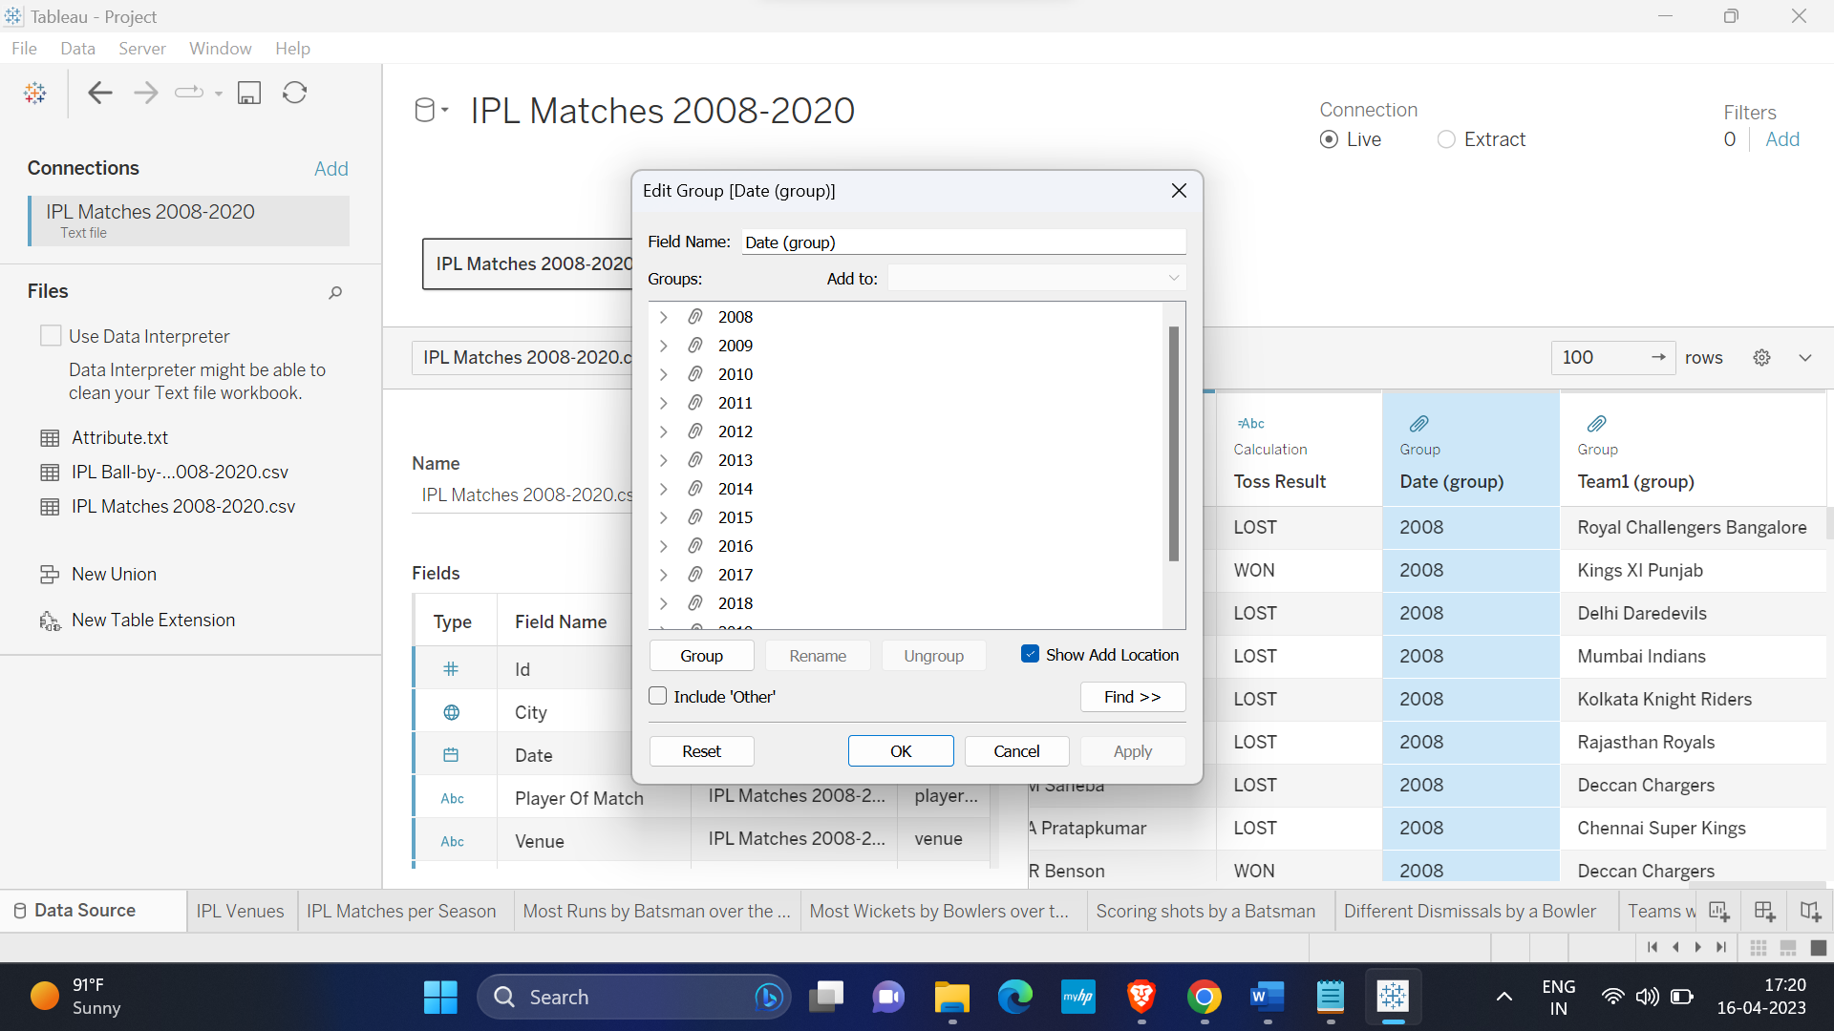

1. Create a group for and group for Team 1(based on team)

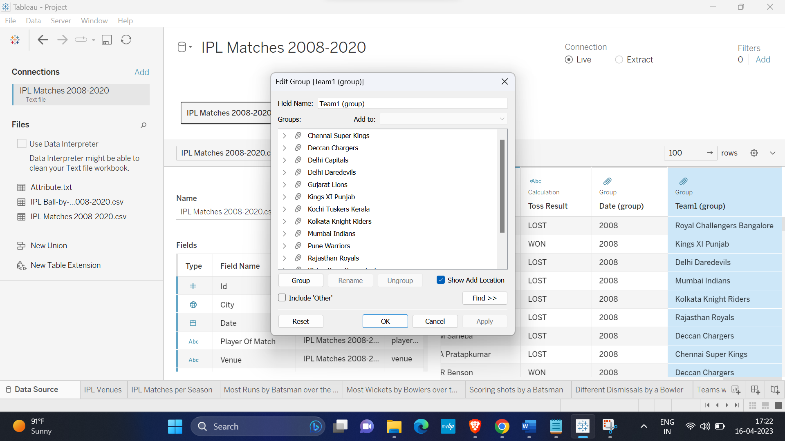

1. Create a group batsman runs (based on the runs scored i.e, 1’s, 2’s 3’s, 4’s, 5’s and 6’s).

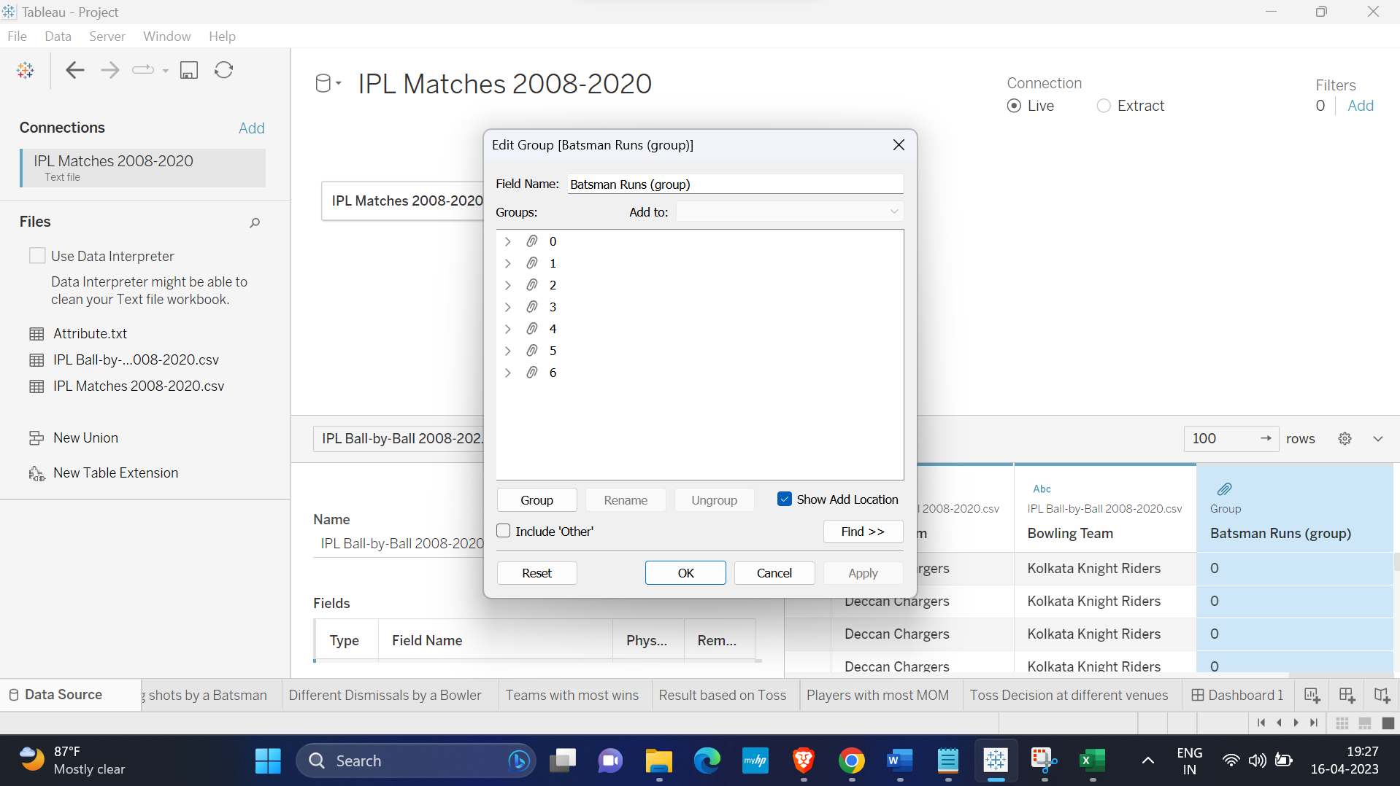

**Section III: Potential Dashboard Users:**

* IPL team owners and management - Team owners and management may want to analyze the performance of their team and players over the course of the tournament. They may want to track key performance indicators such as win-loss ratios, player performance statistics, and team rankings.
* Sports analysts - Analysts who specialize in cricket and IPL matches may use the dashboard to gain insights into player and team performance. They may also use the dashboard to track trends and patterns over multiple seasons.
* Media and broadcasters - Media companies and broadcasters may use the dashboard to prepare for pre-match analysis, post-match analysis, and live commentary during the matches. They may use the dashboard to track player and team statistics, identify key trends, and provide insights to viewers.
* Betting companies - Betting companies may use the dashboard to identify potential bets, calculate odds, and track real-time match statistics. They may use the dashboard to identify players and teams that are likely to perform well and to adjust their betting strategies accordingly.
* Fantasy sports companies - Fantasy sports companies may use the dashboard to track player statistics and create fantasy teams. They may use the dashboard to identify players who are likely to perform well and to provide real-time updates to their users.
* Fans - Fans of the IPL may use the dashboard to track their favourite teams and players, follow the latest news and updates, and participate in online discussions. They may use the dashboard to track real-time match statistics and to predict the outcome of upcoming matches.
* Coaches - Coaches of IPL teams could use a dashboard to analyze player and team performance data, identify strengths and weaknesses, and make informed decisions about game strategy.

**Section IV: List of Questions**

1. How many Matches are hosted in different cities?
2. Display the Number of matches played per season?
3. Display the most runs scored by a batsman both overall and during a season?
4. Display the most number of wickets taken by a bowler overall and during a season?
5. Display the most scored runs (1s,2s,3s,4s,6s)?
6. Explain various dismissals made by a bowler?
7. Display the team with most wins.
8. Result when the toss is won or lost?
9. Display the players with most MOM?
10. Display the toss decisions at different venues?

**Section V: Dashboard Plots**

1. Question: How many Matches are hosted in different cities?

This graph shows the matches held at different parts of the world. The pre attentive attributes are size

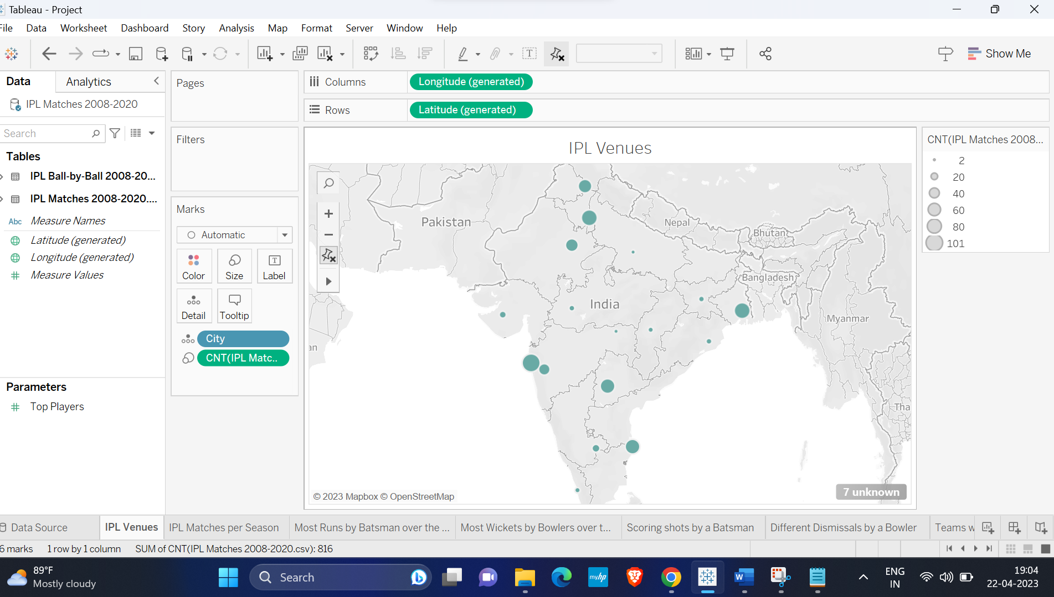

1. Question: Display the Number of matches played per season?

This graph displays the number of matches played per season over the years 2008 to 2020. The pre attentive attributes are position

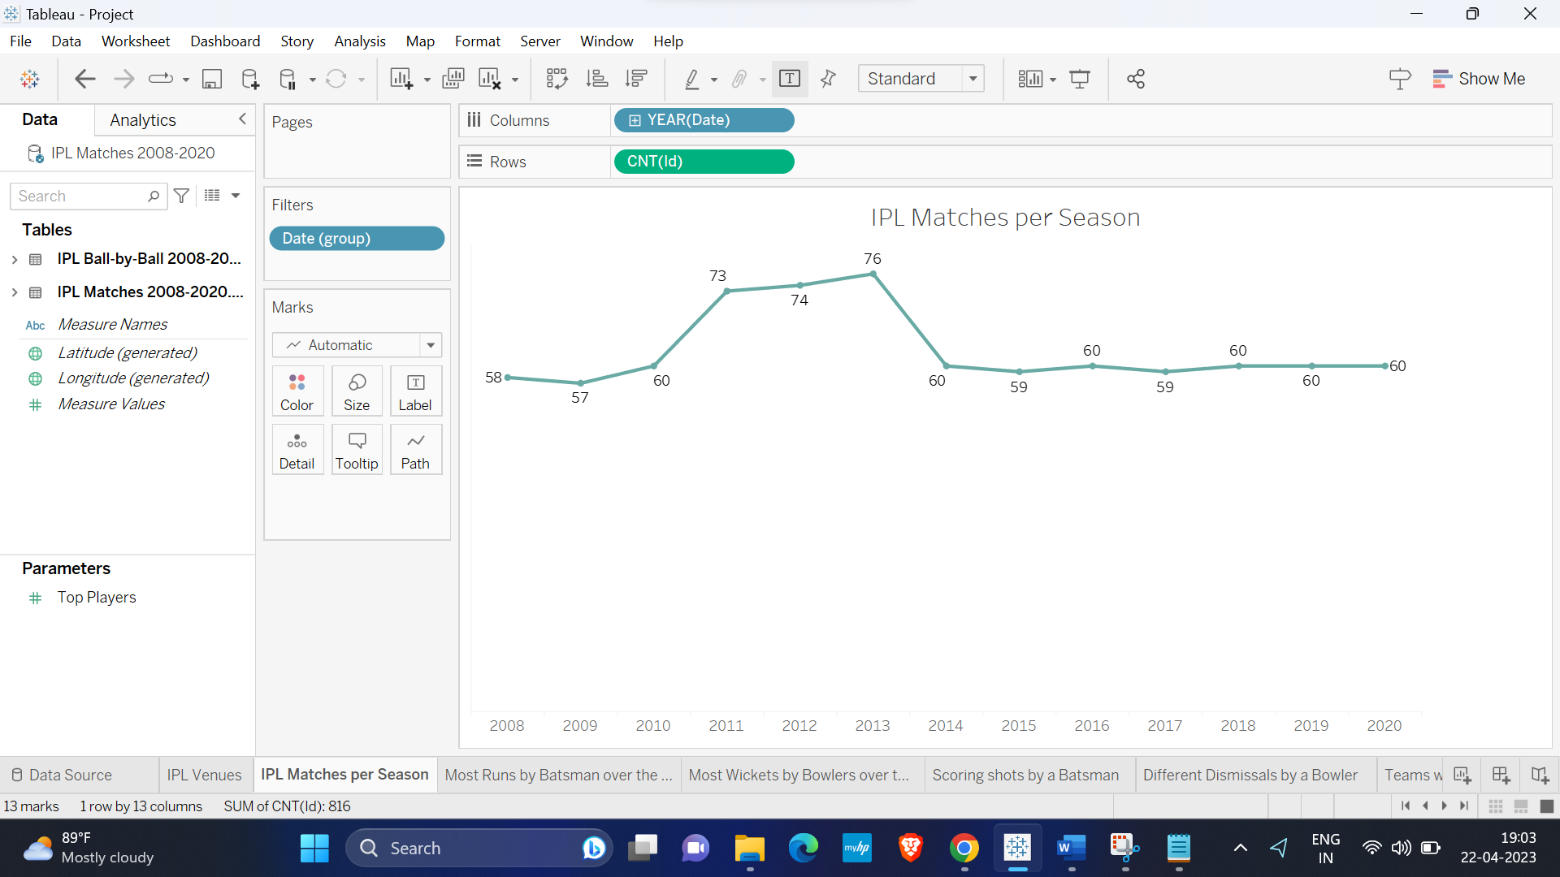

1. Question: Display the most runs scored by a batsman both overall and during a season?

This graph displays the most runs scored by a batsman both overall and during a season. The pre attentive attributes are length

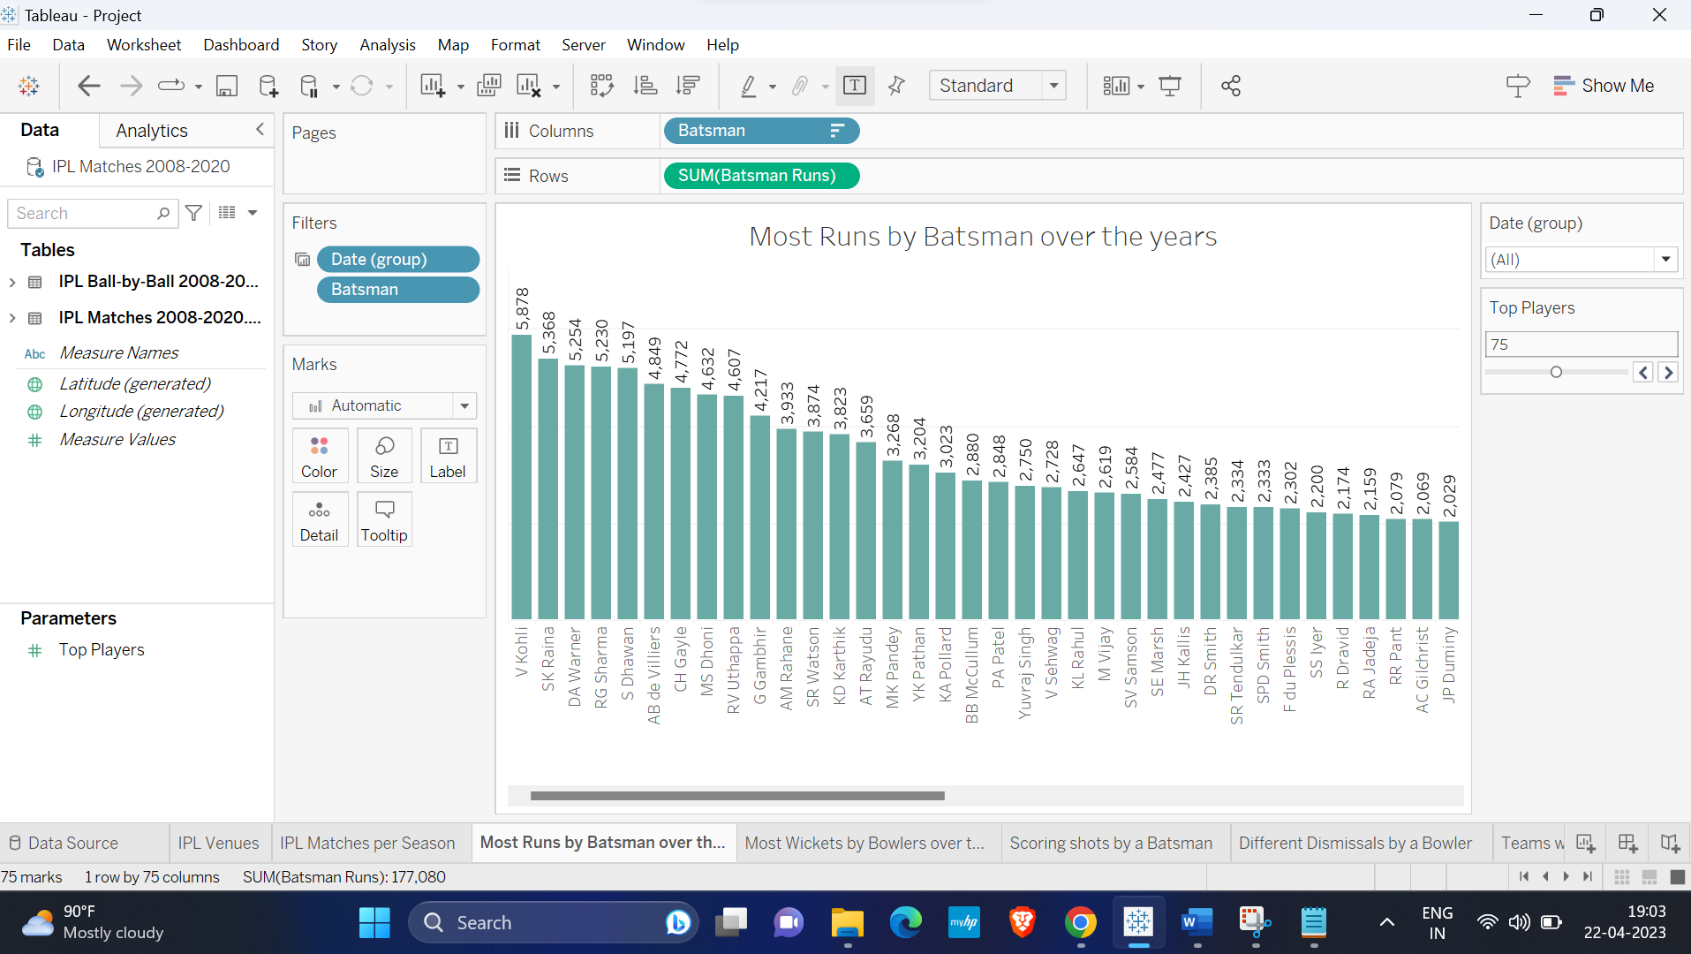

1. Question: Display the most number of wickets taken by a bowler overall and during a season?

The below visualization shows the most number of wickets taken by a bowler overall and during a season. The pre attentive attributes used are length

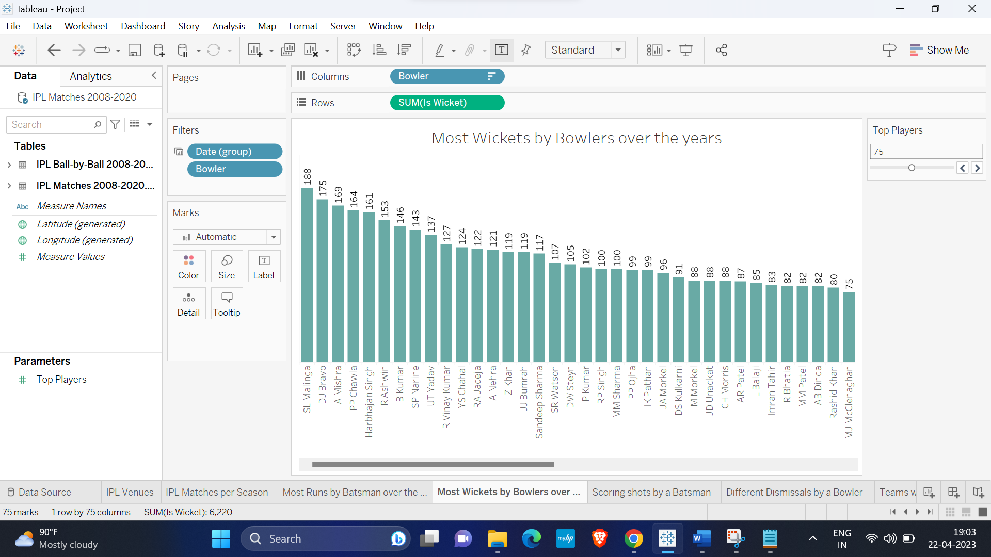

1. Question: Display the most scored runs (1s,2s,3s,4s,6s)?

This graph display’s the most scored runs (1s,2s,3s,4s,6s). The pre attentive attributes used are color and size

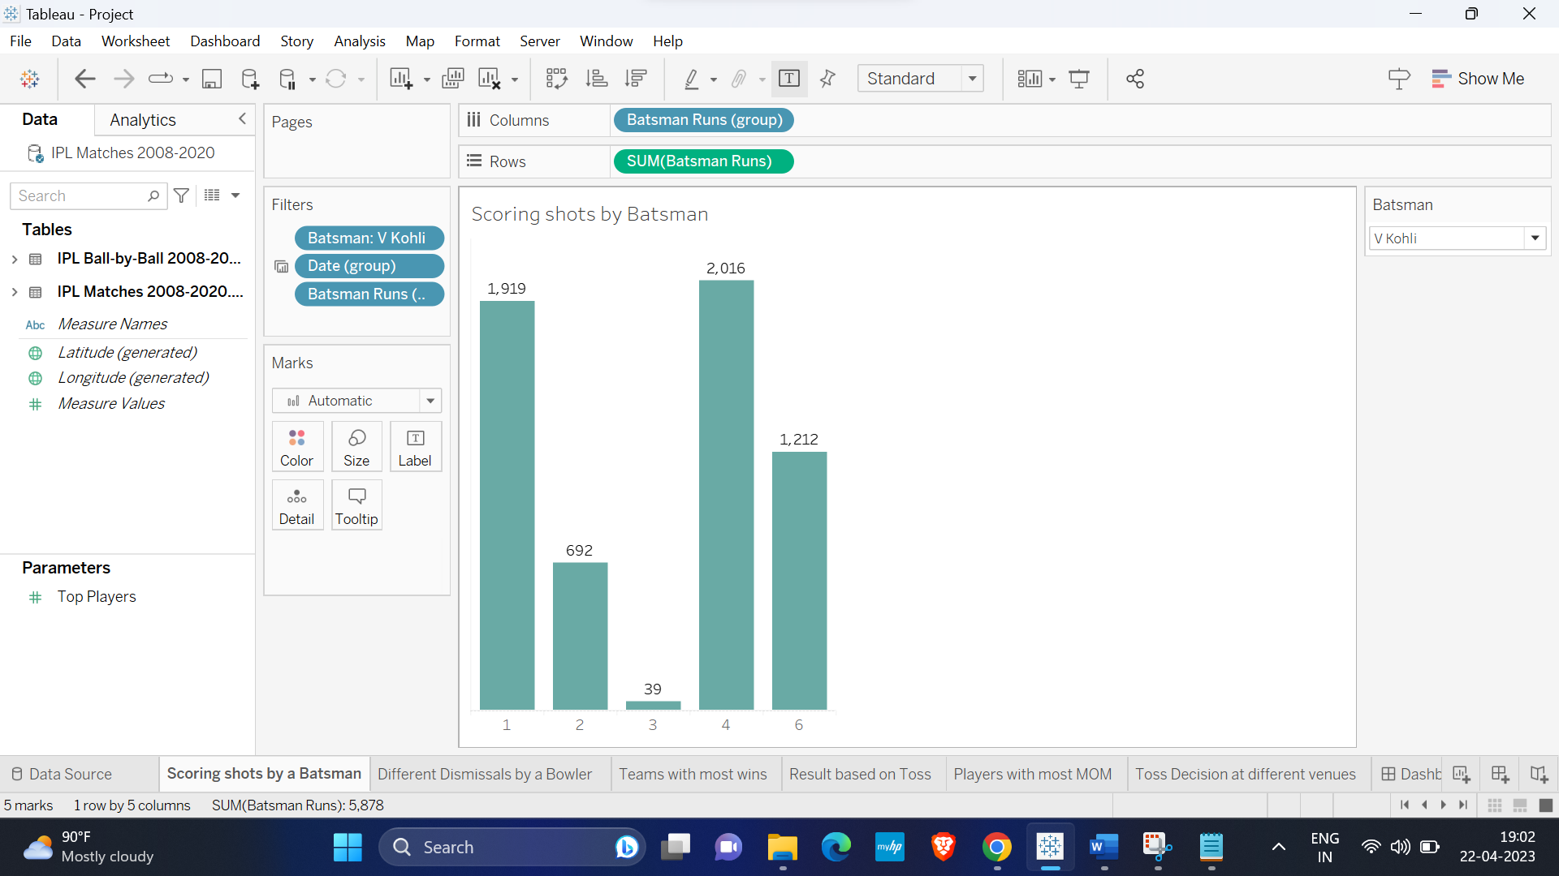

1. Question: Explain various dismissals made by a bowler?

This graph display’s the various dismissals made by a bowler. The pre attentive attributes used are length

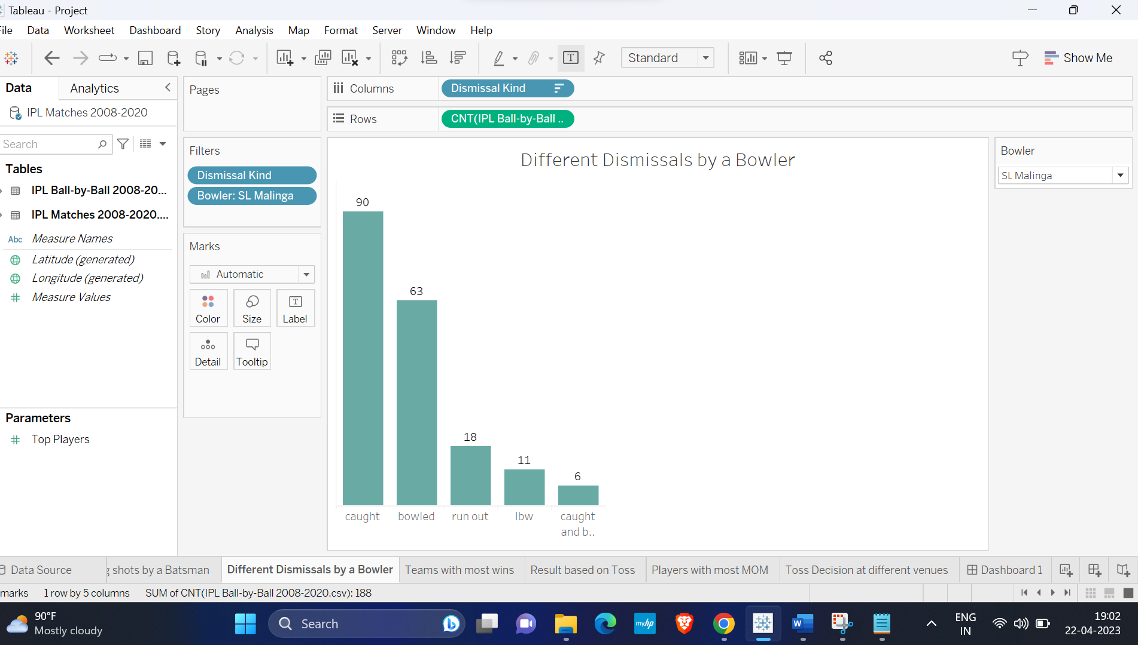

1. Question: Display the team with most wins.

This graph display’s the team with most wins over the years. The pre attentive attribute used are length.

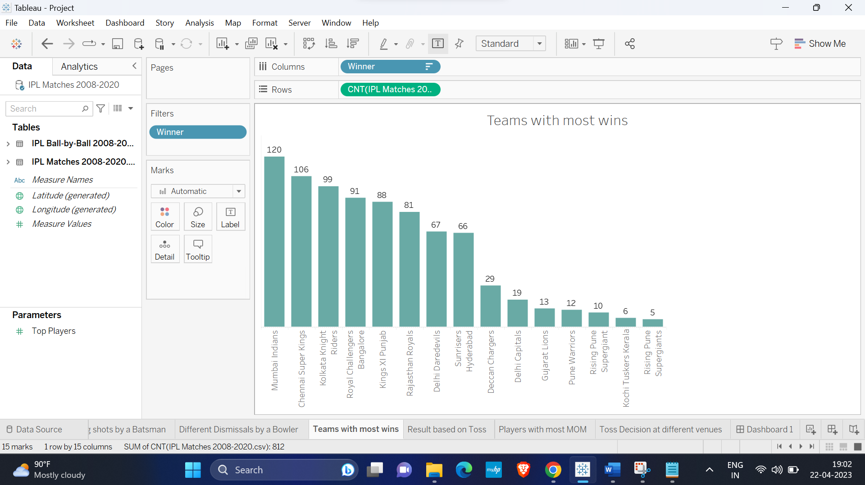

1. Question: Result when the toss is won or lost?

This graph display’s result when the toss is won or lost. The pre attentive attributes used are color intensity

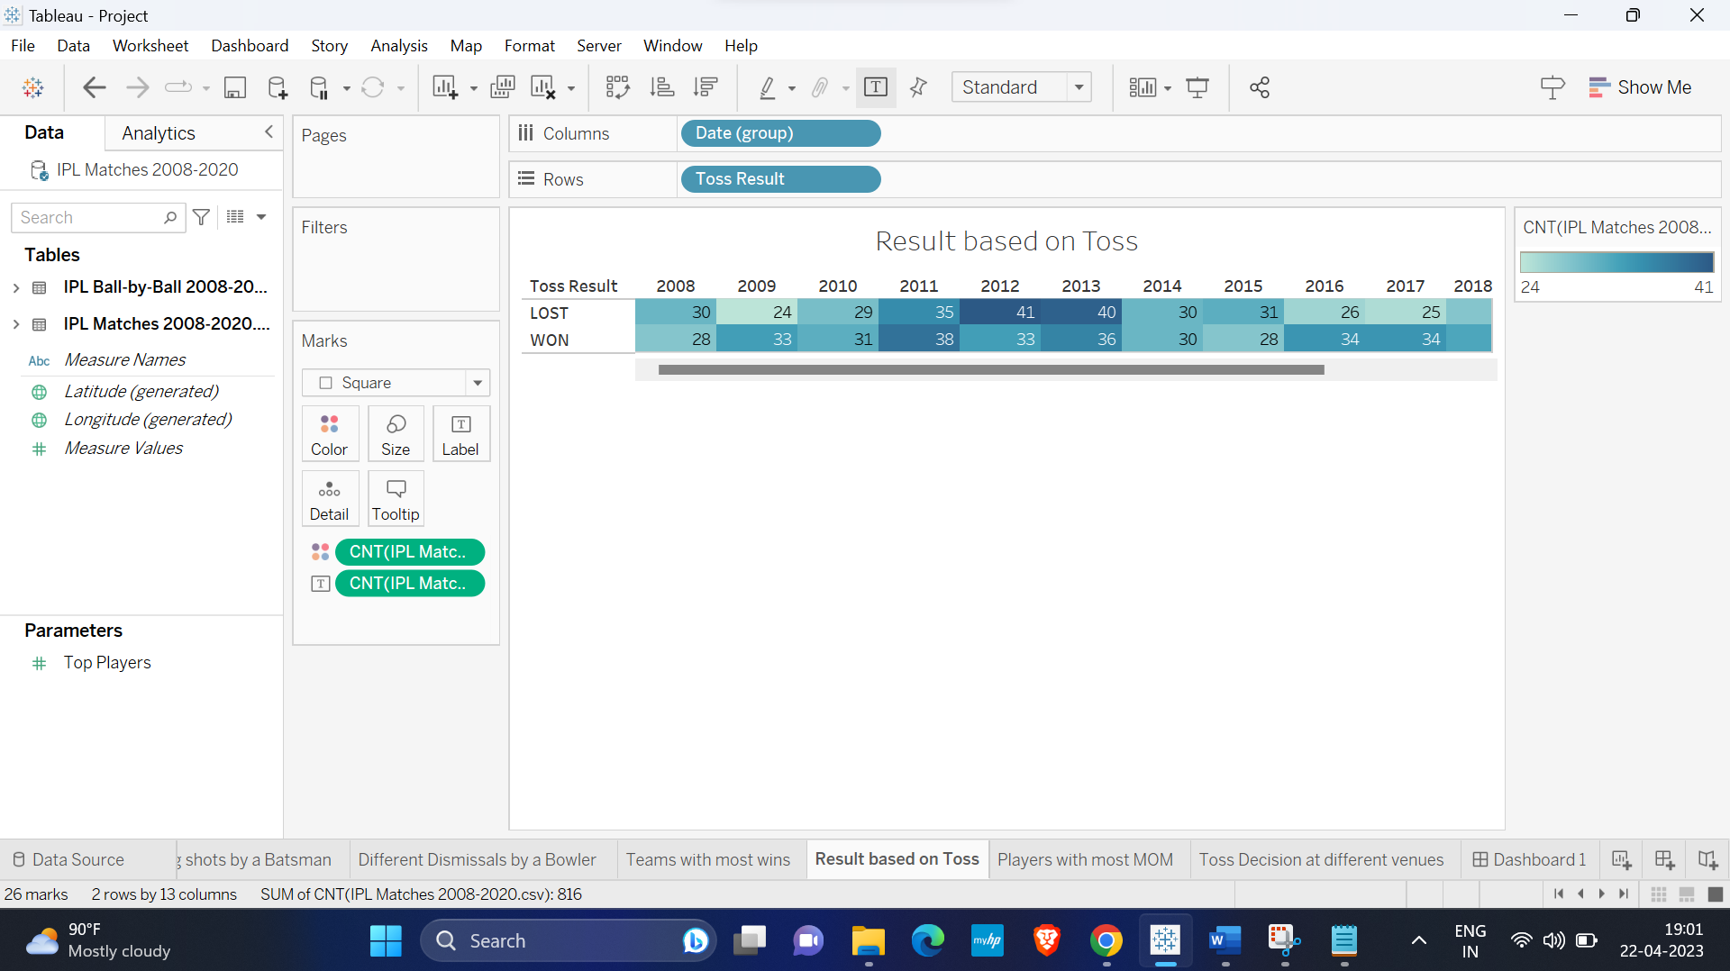

1. Question: Display the players with most MOM?

This graph display’s the players with most Man Of the Match. The pre attentive attributes used are length

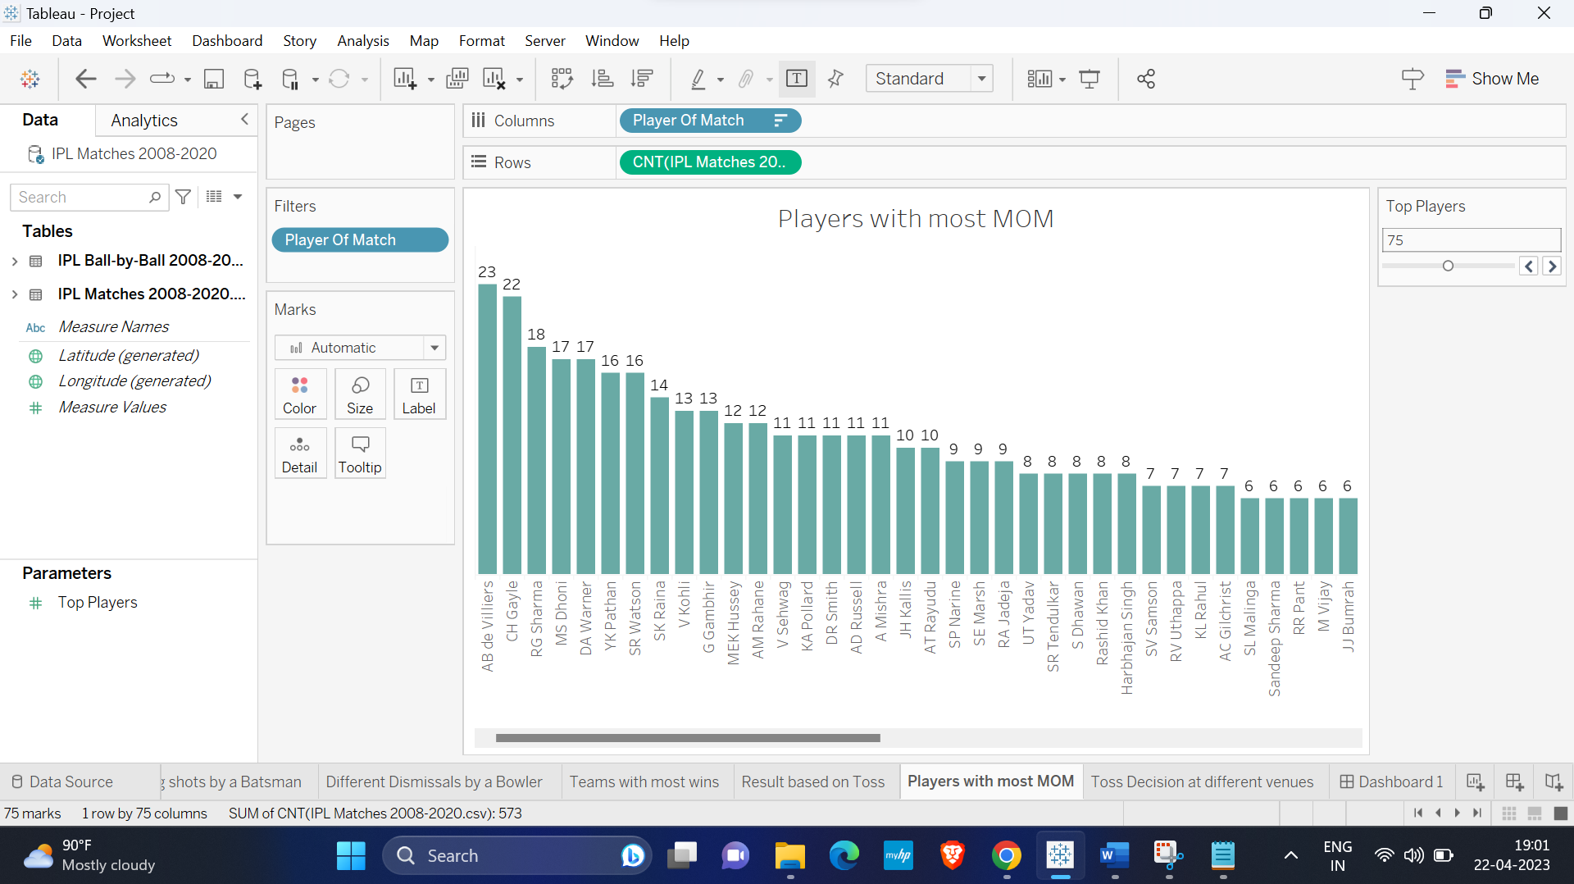

1. Question: Display the toss decisions at different venues?

This graph display’s the toss decisions at different venues. The pre attentive attributes used are length and color.

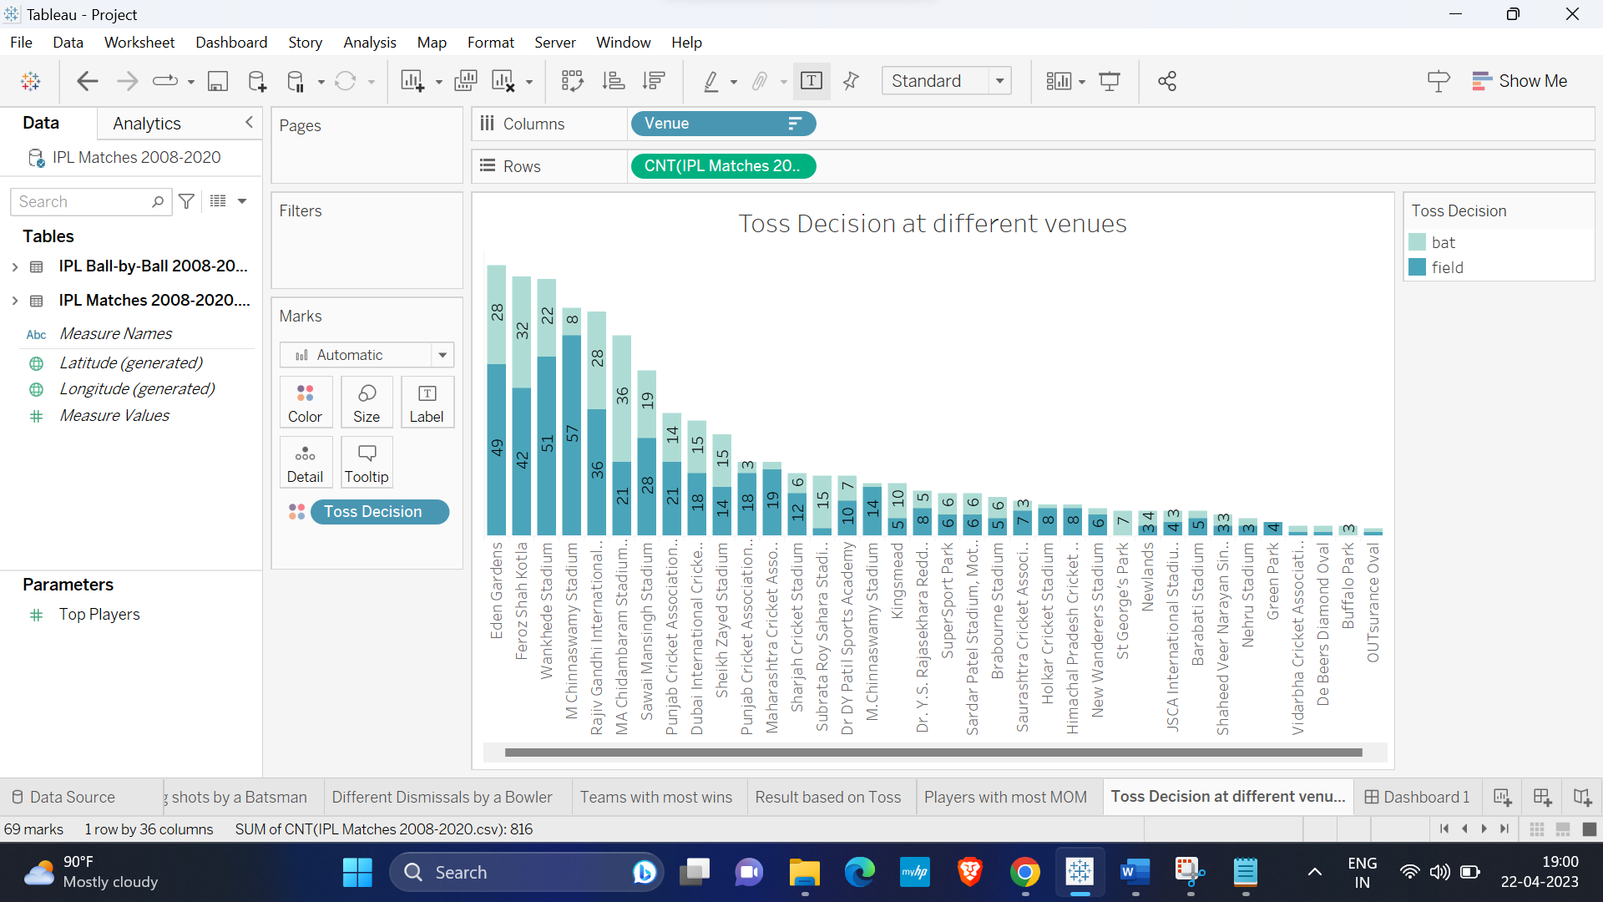

**Section VI: Dashboard Interactivity**

In the dashboard we have create a group for date and linked to visualizations such as Most runs by batsman over the years, Most wickets by bowlers over the years and Scoring shots by batsman. We have created a parameter names Top players and linked to visualizations Most runs by batsman over the years and Most wickets by bowlers over the years. For showing different dismissals of bowlers, we used bar chart with bowler name as filter. Bar chart is used for displaying scoring of the runs and with the change of the batsman name, the graph changes. In order to enhance the level of interaction, the parameters are connected to the pre-existing fields, making it simpler for prospective users to navigate and explore the available data.

Tableau Public:

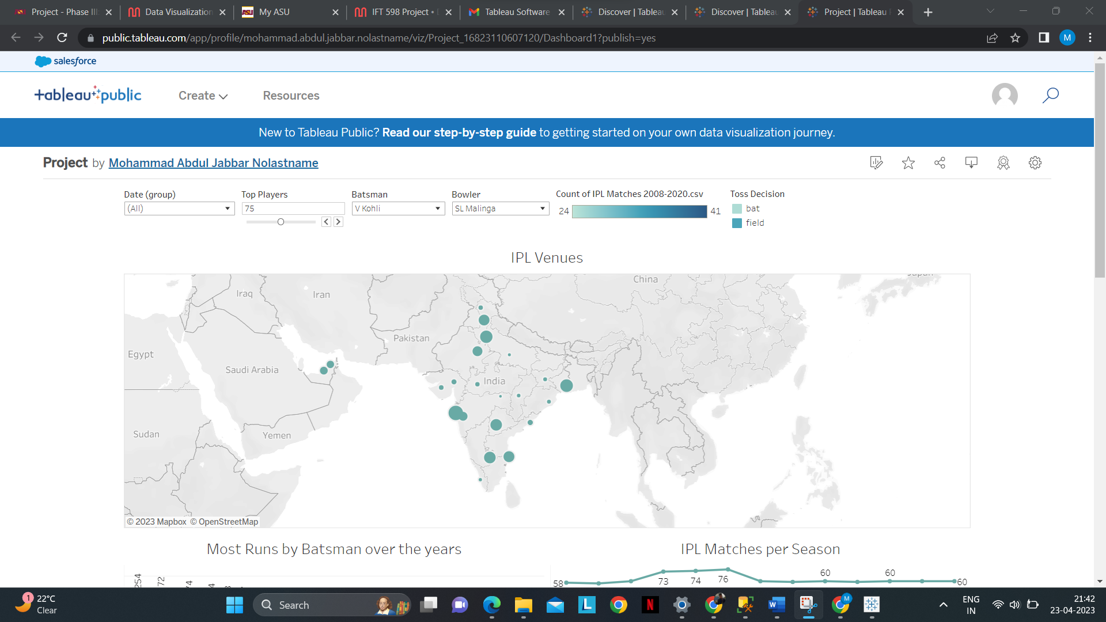

**References, Mural Link**

Mural - <https://app.mural.co/t/dvfinalproject6417/m/dvfinalproject6417/1680728836627/1f81b1a12f7175f731446d113e920bfd01e565d1?sender=uab742469b088e2b4a49b6951>

Dataset Source - <https://www.kaggle.com/code/yekahaaagayeham/ipl-analysis-with-tableau/input>

Tableau Public - <https://public.tableau.com/app/profile/mohammad.abdul.jabbar.nolastname/viz/Project_16823110607120/Dashboard1?publish=yes>